Fatima Sroor School Worksheets –King Lear 12th Grade
Teacher: Lana Khalid Literature
Objectives:
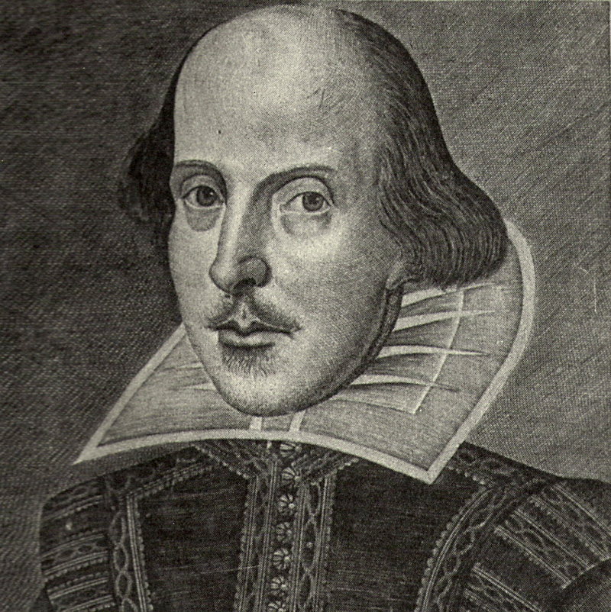
- To appreciate literary works.
- To encourage creativity and develop imagination.
- To empower students language abilities and skills.

Activity One:
Introducing the writer: let’s interview Shakespeare and ask him questions.

1-When were you born? Where?
……………………………………………………………………………………………………………………………………….
2-What kind of writer are you?
………………………………………………………………………………………………………………………………………
3-What are you remarkable for?
………………………………………………………………………………………………………………………………………
4-How many plays did you write?
………………………………………………………………………………………………………………………………………
5-Who acted your plays? Where?
……………………………………………………………………………………………………………………………………….
6-When did you write King Lear? Where is the story taken from?
……………………………………………………………………………………………………………………………………….
7-To whom did you dedicate King Lear? Why?
……………………………………………………………………………………………………………………………………….
8-What was the effect of the play on social life in England?
……………………………………………………………………………………………………………………………………….

Activity Two: Fill in the blanks with the suitable names of characters.
King Lear Family Tree

………………………………
Fool
Earl of Gloucester

Sons
Nobleman
………………………
also …………………
…………………….
Nobleman
Illegitimate
Legitimate
King Lear

The Youngest
………………………………..
The Second
……………………………….

Daughters

The Oldest
…………………………….

Servant
…………………
Husband
…………………………….
Suitor
………………………………..
Husband
………………………………..
Husband
……………………………….

Activity Three:
Match Characters to verbs then write as many suitable sentences as you can.
…………………………………………………………………………………………………..
…………………………………………………………………………………………………..
…………………………………………………………………………………………………..
…………………………………………………………………………………………………..
…………………………………………………………………………………………………..
…………………………………………………………………………………………………..
…………………………………………………………………………………………………..
…………………………………………………………………………………………………..
…………………………………………………………………………………………………..
…………………………………………………………………………………………………..
…………………………………………………………………………………………………..
…………………………………………………………………………………………………..
…………………………………………………………………………………………………..
…………………………………………………………………………………………………..
…………………………………………………………………………………………………..
Edmund
Regan and
Goneril
Gloucester
Kent
Lear
Edgar
Cornwall
Cordelia
Albany

boasted
advised
realised
disguised
pretended
went mad
betrayed
punished
fell in love
forgave
suffer
dismissed
blinded
poisoned

…………………………………………………………………………………………………………………………………………………………………
…………………………………………………………………………………………………………………………………………………………………
…………………………………………………………………………………………………………………………………………………………………

Activity Four:
Work individually for 10 minutes to the write an informal letter, then in groups of 4 compare your designs and present one letter.
Write the letter from Goneril to Regan who complained about their father and warned her sister that his 100 men were two noisy and expensive. (eat and drink much, workless, needless, accept only 25, send away all of them, feel, no love no kindness, disturb, ask many questions, old and weak).

Dear Regan,
…………………………………………………………………………………………………………………………………………
……………………………………………………………………………………………………………………………………………………
……………………………………………………………………………………………………………………………………………………
……………………………………………………………………………………………………………………………………………………
……………………………………………………………………………………………………………………………………………………
……………………………………………………………………………………………………………………………………………………
……………………………………………………………………………………………………………………………………………………
……………………………………………………………………………………………………………………………………………………
……………………………………………………………………………………………………………………………………………………
……………………………………………………………………………………………………………………………………………………
……………………………………………………………………………

Goneril

Activity Five:
Match proverbs to the events of the play.
- Don’t cross the bridge before you come to it.
…………………………………………………………………………………………………………………………………………
- Do as you would be done by.
…………………………………………………………………………………………………………………………………………
- All is not gold that glitters.
…………………………………………………………………………………………………………………………………………
- As you sow, so will you reap.
…………………………………………………………………………………………………………………………………………
- Still water runs deep.
…………………………………………………………………………………………………………………………………………
- Better be sure than sorry.
…………………………………………………………………………………………………………………………………………
- Birds of a feather flock together. …………………………………………………………………………………………………………………………………………
- Blood is thicker than water.
…………………………………………………………………………………………………………………………………………
- Deeds, not words.
…………………………………………………………………………………………………………………………………………
- Easy come, easy go.
…………………………………………………………………………………………………………………………………………
- A friend in need is a friend in deed.
…………………………………………………………………………………………………………………………………………
- Every dog has its day.
…………………………………………………………………………………………………………………………………………

Activity Six:
Every character committed sins. Work individually to summarise each character’s sins.
Example:
King Lear: 1- He failed to understand the real emotions of his daughters.
2- He gave up his power and authority earlier than he should do.
Goneril: ……………………………………………………………………………………………………………………………..
……………………………………………………………………………………………………………………………..
Regan: ……………………………………………………………………………………………………………………………..
……………………………………………………………………………………………………………………………..
Cordelia: ……………………………………………………………………………………………………………………………..
……………………………………………………………………………………………………………………………..
Gloucester: …………………………………………………………………………………………………………………………..
…………………………………………………………………………………………………………………………
Edgar: ……………………………………………………………………………………………………………………………..
……………………………………………………………………………………………………………………………..
Edmund: ……………………………………………………………………………………………………………………………..
……………………………………………………………………………………………………………………………..
Duke of Cornwall: ……………………………………………………………………………………………………………………..
……………………………………………………………………………………………………………………..
Duke of Albany: ……………………………………………………………………………………………………………………..
In your opinion:
Who is the worst character in the play? Why? ………………………………………………………………
Who’s the best character? Why? …………………………………………
What is the best lesson you learned from the play? ………………………………………..
Activity seven:
Draw a moving scene from the play :for example , Lear comes carrying Cordelia dead in his arms.

